What do you know?

Circle the **larger fraction** and **explain** in words how you know that the fraction is larger. Use a manipulative and model the fractions to verify their selection.

 

 

 

 

 

**Part of One Whole:** This is when one unit is partitioned into equal parts.



**Part of a Set:** The equal parts into which one whole is divided are equal but do not have to be identical. Therefore, sets can contain different items or different shapes. For example, in a group of 8 people, there may be 5 children, 2 women, and 1 man. What is the fraction of the set represented by the children? Women? Man?

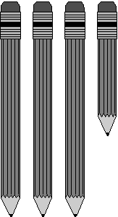

**Part of a Measure:** Fractions of measure involve the measure of length such as finding a fractional unit on a number line

Show all the ways to make one half? Show all the ways to make one quarter?