Gathering Personal Artefacts

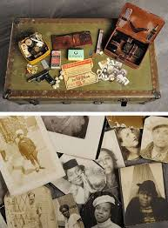
Artefacts are objects that are made and used by people. Tools, clothing, pots, ornaments, and drawings are all examples of artefacts.

We have been learning about artefacts and how they can be used to give clues as to how people lived in the past. Artefacts are objects that are made and used by people. Tools, clothing, pots, ornaments, and drawings are all examples of artefacts.

Your assignment:

- Find an artefact that is important or has special meaning to you.
Example: Photograph, ticket stub, newspaper clipping, cards, etc.

- Bring the artefact to school. If possible, you will glue or tape the artefact into your writer’s notebook. Some artefacts will not fit in your notebook.
Example: hockey puck, coin, special toy, etc. We will take a photograph of these artefacts and glue them into your notebook.

There is a story or memory behind every artefact. On Tuesday, October 24th, you will use your artefact (be sure to bring it to class) to spark a writing idea.

